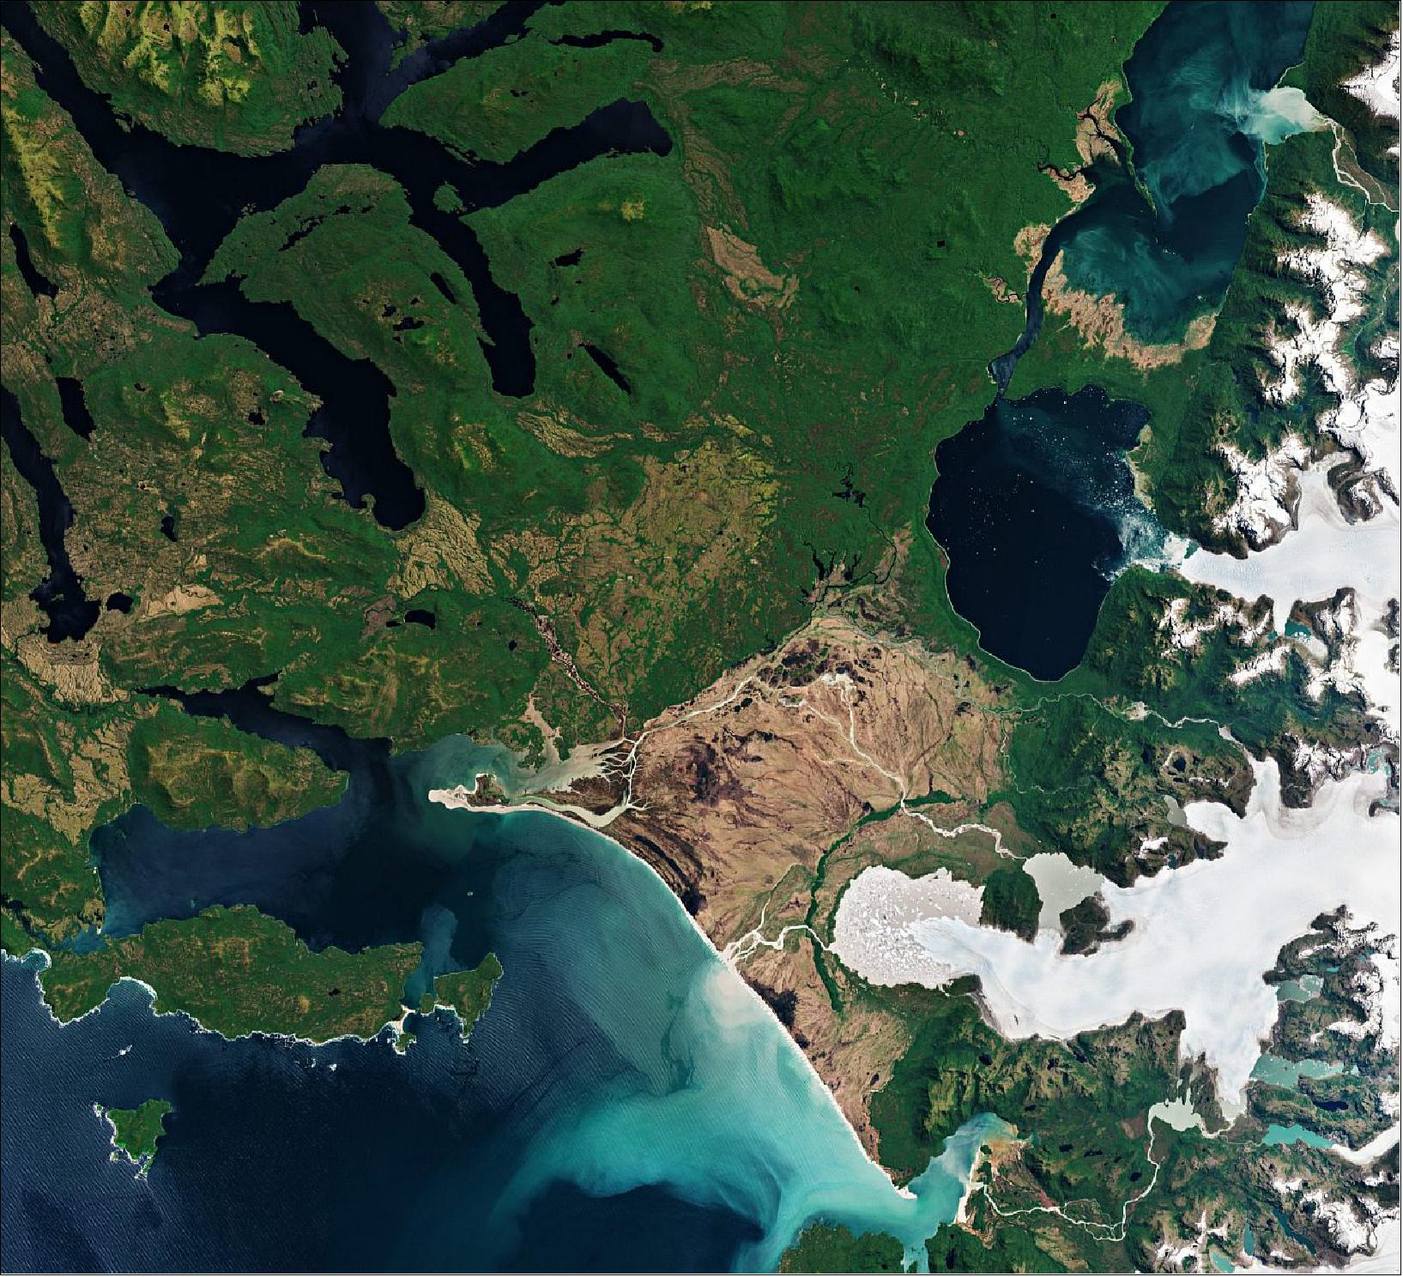
Figure 11: The image depicts the west part of the Northern Patagonian Ice Field which has 28 exit glaciers, with the largest two, San Rafael and San Quintín, visible here. San Rafael Glacier, which can be seen in the upper-right of the image, is one of the most actively calving glaciers in the world and the fastest-moving glacier in Patagonia – ‘flowing’ at a speed of around 7.6 km per year. This image is also featured on the Earth from Space video program (image credit: ESA, the image contains modified Copernicus Sentinel data (2018), processed by ESA, CC BY-SA 3.0 IGO)

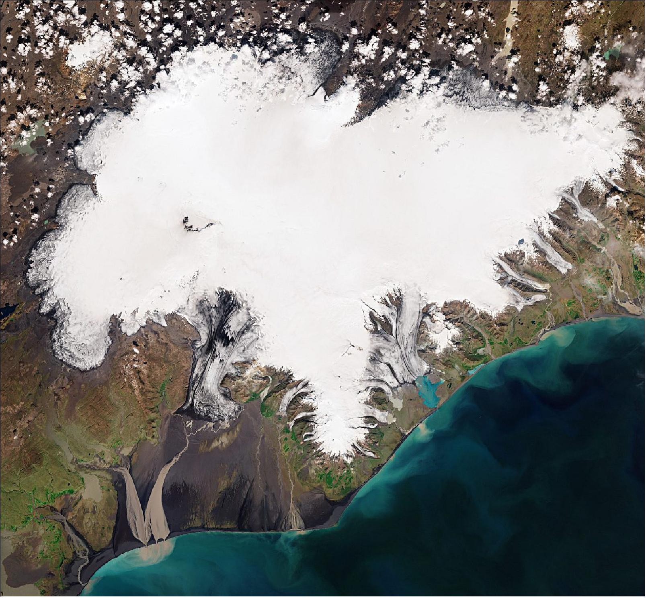 Figure 14: Covering an area of around 8400 km2, which is three times the size of Luxembourg, Vatnajökull is not only classified as the biggest glacier in Iceland, but the biggest in Europe. With an average ice thickness of around 900 m, the ice cap has about 30 outlet glaciers – many of which are retreating owing to warming temperatures. This image is also featured on the Earth from Space video program (image credit: ESA, the image contains modified Copernicus Sentinel data (2019), processed by ESA)

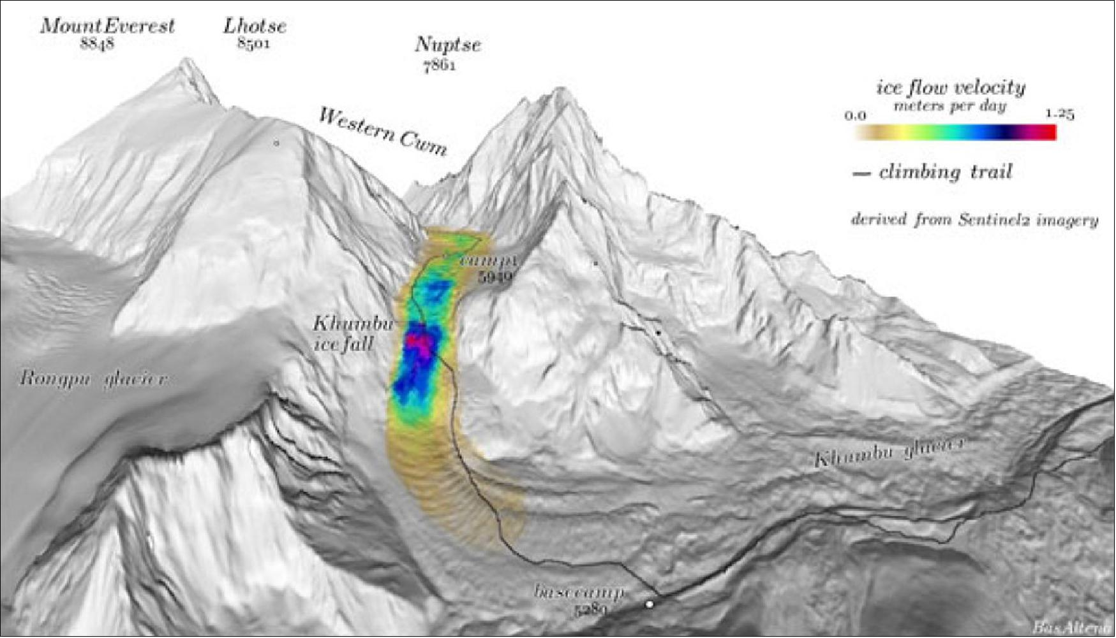
Figure 16: Color-coded icefall velocities at Khumbu Glacier. 3D rendering of the extracted velocity field over Khumbu icefall. The trail to basecamp and through the icefall is indicated by the black line (image credit: Bas Altena, University of Oslo)

Figure 17: The Nioghalvfjerdsfjorden Ice Shelf, also known as 79N, is the floating front end of the Northeast Greenland ice stream - where it flows off the land and out into the ocean. At its leading edge, the 79N glacier splits in two, with offshoot turning north. It's this offshoot, or tributary, called Spalte Glacier, that has now disintegrated (image credit: ESA, the image series contains modified Copernicus data (2020), processed by ESA)
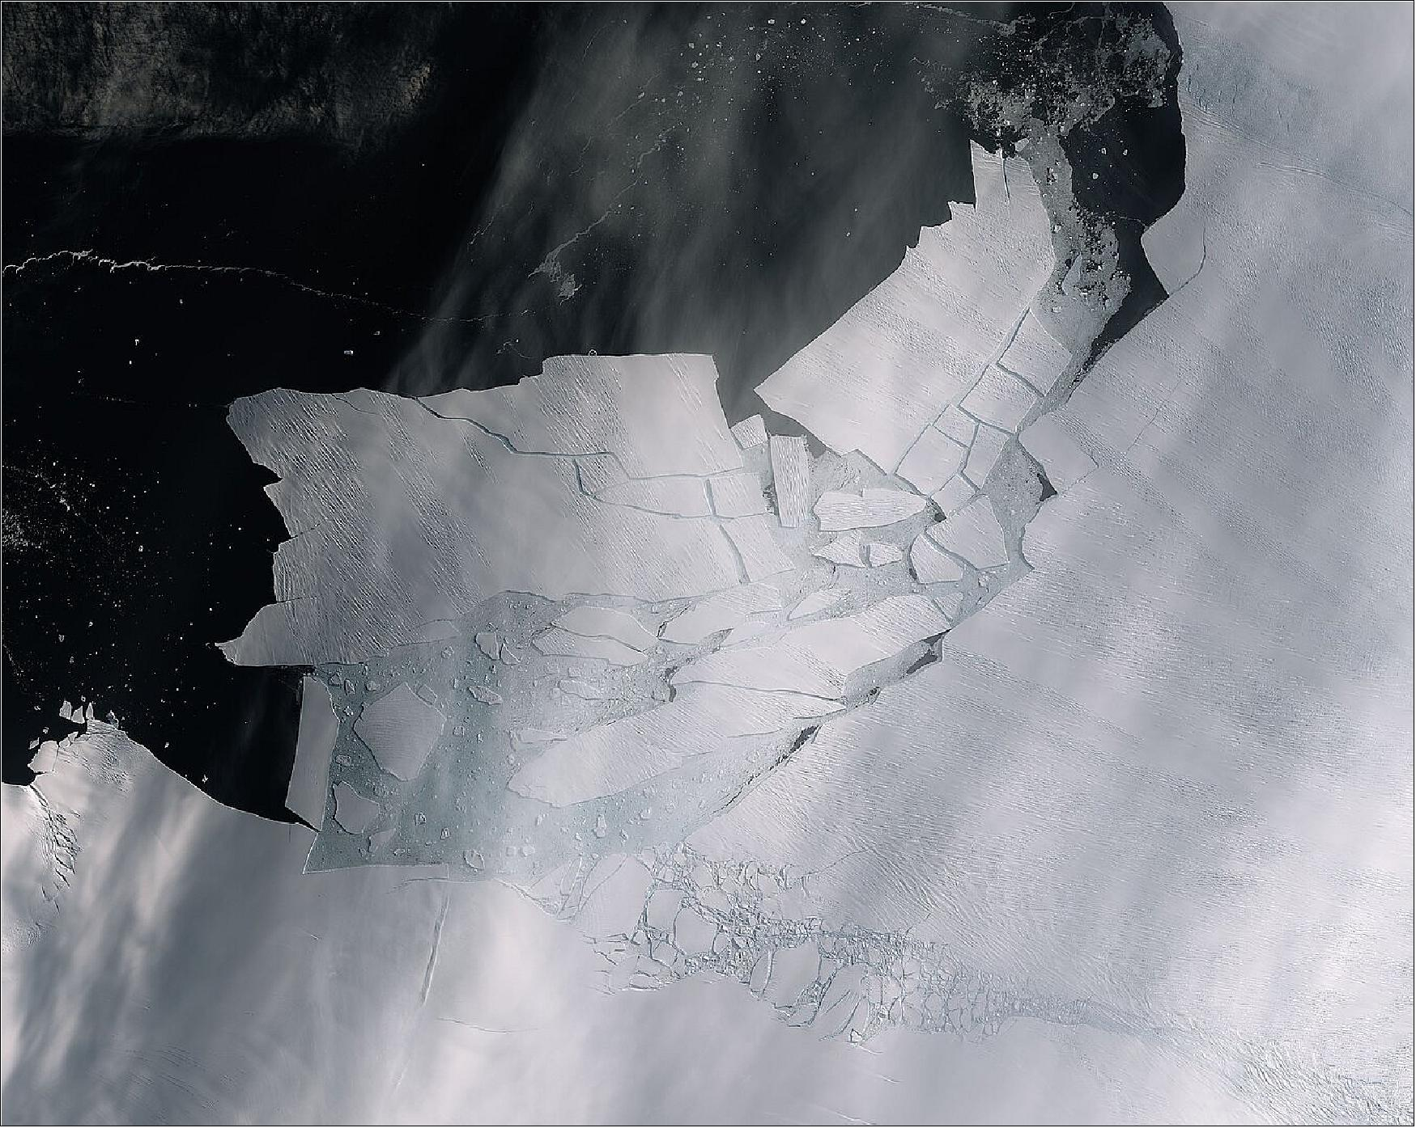
Figure 62: This image of the Pine Island Glacier, captured on 11 February 2020 by the Copernicus Sentinel-2 mission, shows the freshly broken bergs in detail (image credit: ESA, the image contains modified Copernicus Sentinel data (2020), processed by ESA, CC BY-SA 3.0 IGO)

